**Setting User Frames Using Automatic Grid Frame Set**

Make sure the camera has been focused, and aperture has been set (see other document)

**Pallet Frames Right Side:**

1. Run the “JR_CALIRIGHTSIDE” TP program. This will move the robot EOAT over Pallet Position 7.

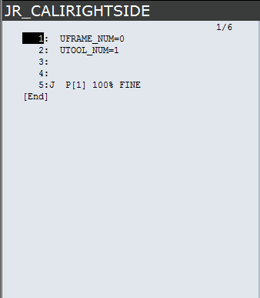

1. Load a pallet at position 7 and place the Calibration Plate on the pallet. Make sure that the X, Y orientation matches the robot world frame (images below). 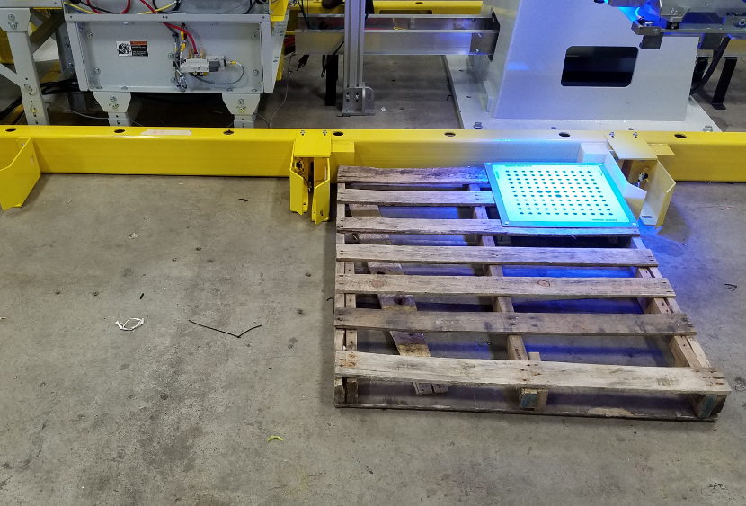

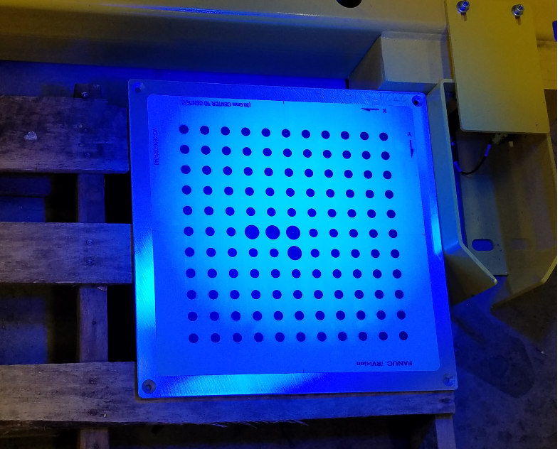

1. With the robot and grid in position, you can run the Automatic Grid Frame Set function on the robot teach pendent.
   1. Menu
   2. IRVision
   3. Vision Utilities
   4. Automatic Grid Frame Set
   5. Detail (F3)
   6. Arrow down the Start Position, and press Record (F4)
   7. Enter the values shown below for items 1-12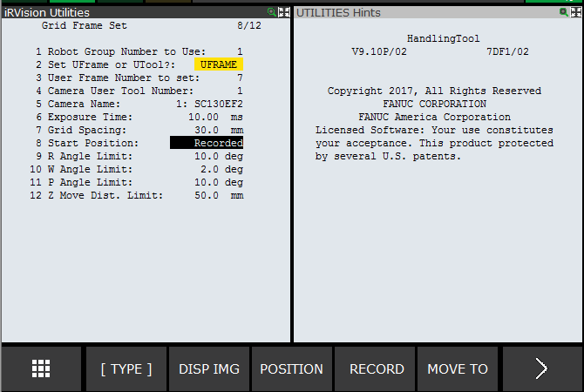
2. Once the starting position has been recorded, and all values set, you can execute the grid frame set function. CAUTION, Robot is going to move once you start!
   1. Make sure Start Position is not highlighted.
   2. While holding the enable switch and shift, press execute.

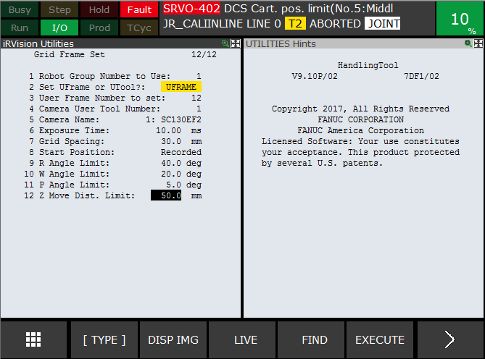

* 1. Once complete, the user frame will be taught for Pallet POS 7.

1. Now that the frame is taught, you need to record the Master Height. Run the Rightside_Height program.

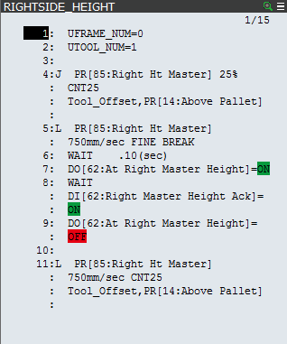

**Pallet Frames Left Side:**

1. Run the “JR_CALILEFTSIDE” TP program. This will move the robot EOAT over Pallet Position 4. 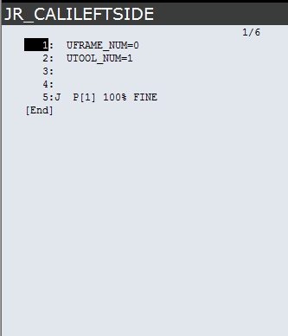
2. Follow steps 2 and 3 from above. Load Pallet into position 4, with grid.
3. With the robot and grid in position, you can run the Automatic Grid Frame Set function on the robot teach pendent.
   1. Menu
   2. IRVision
   3. Vision Utilities
   4. Automatic Grid Frame Set
   5. Detail (F3)
   6. Arrow down the Start Position, and press Record (F4)
   7. Enter the values shown below for items 1-12 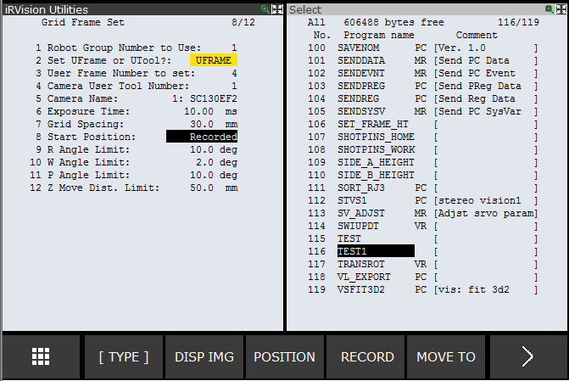
4. Repeat step 4 from above. Once complete, the user frame will be taught for Pallet POS 4.
5. Now that the frame is taught, you need to record the Master Height. Run the Leftside_Height program.

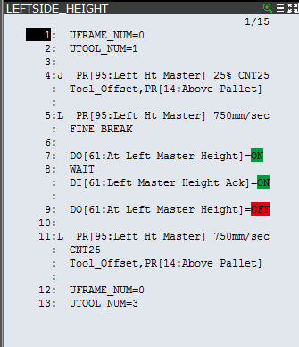

1. Lastly, Run the JR_UFCONFIG TP program to set the rest of the Pallet User Frames. 